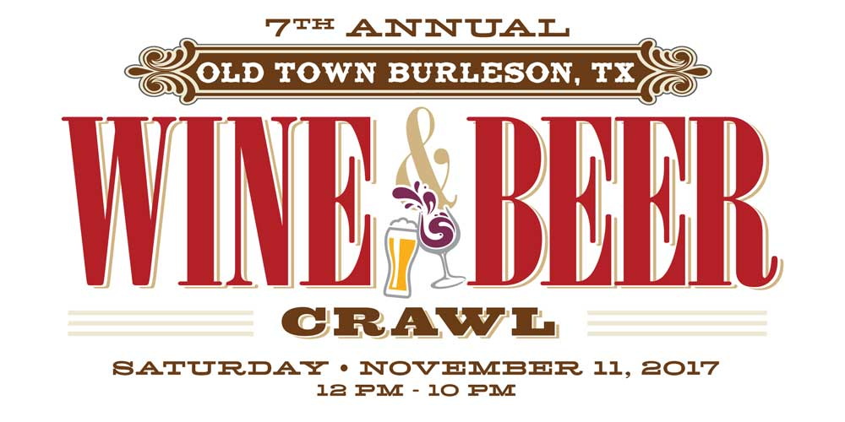

Saturday, November 11, 2017 from 12 p.m. to 10 p.m. in Old Town Burleson
Artisan Vendor Application and Agreement
The Seventh Annual Old Town Burleson Wine Crawl (“Wine Crawl”), sponsored by Ritz Event Company, LLC, promotes growth and exposure of Burleson and its Old Town community. The Wine Crawl features vendors, live music, wine sampling, cold beer, food, and more. A crowd of approximately 7,000 is anticipated. A portion of the proceeds from the Wine Crawl will benefit Burleson charities such as Crazy 8 Ministries.
Ritz Event Company, LLC invites you to apply to participate as an Artisan Vendor in the Wine Crawl. Tents (10 feet by 10 feet) (or Booths) will line the streets of Old Town Burleson and be made available for approved Vendors (Artisan, Kids Zone, Food, etc.).
Name of Business:
Contact Name: Phone:
Business Address:
Website Address:
Email Address:

Please list the items that will be available for purchase at your Booth. Attach additional sheet(s) if necessary:

Please indicate the price range of the items:

PLEASE SUBMIT IMAGES (MINIMUM OF THREE), EITHER ON CD OR PRINTED, OF ITEMS THAT WILL BE AVAILABLE FOR PURCHASE AT YOUR BOOTH AND/OR A PHOTO OF YOUR BOOTH DISPLAY. IMAGES MAY ALSO BE SUBMITTED VIA EMAIL AT RITZEVENTCO@GMAIL.COM.

Please Mark The Booth For Which You Are Registering:
□ $175 Booth Fee (without electricity) □ $250 Booth Fee (with electricity)

Booth Fee: No cash will be accepted. The Booth Fee must be paid by check, money order or PayPal when submitting your Artisan Vendor Application and Agreement. Checks and money orders must be made out to Ritz Event Company, LLC. If your Artisan Vendor Application and Agreement is not approved by Ritz Event Company, LLC, your Booth Fee will be refunded. Send monies through PayPal to ritzeventco@gmail.com.
□ Paying by Check or Money Order □ Paying by Pay Pal

If utilizing PayPal for the Booth Fee, please provide the following information:

Return (1) Executed Artisan Vendor Application and Agreement, (2) Booth Fee,
(3) Images, (4) Texas Sales Tax and Use Permit and (5) IRS Form W-9
By October 23, 2017 To:
Adrianne Argumaniz, Ritz Event Company, LLC
321 NW Renfro, Burleson, Texas 76028
•••••
With Questions, Contact Adrianne Argumaniz at
817.917.7327 or ritzeventco@gmail.com

GENERAL INFORMATION AND AGREEMENT

By reading this information and signing this Agreement, you are agreeing to the following. The term “Vendor” applies to you if your Artisan Vendor Application and Agreement has been accepted by Ritz Event Company, LLC.

The following must be submitted with the Artisan Vendor Application and Agreement: (1) Booth Fee; (2) a minimum of three (3) images (which will not be returned); (3) a copy of my Texas Sales Tax and Use Permit; and (4) a copy of insurance

I understand that space is limited for Vendors. I also understand submission of this Artisan Vendor Application and Agreement does not guarantee acceptance. Ritz Event Company, LLC, at its discretion, has the right to refuse this Artisan Vendor Application and Agreement, in which case, the Booth Fee will be refunded to me. Decisions of Ritz Event Company, LLC are final. I will be notified by October 23, 2017 if my Artisan Vendor Application and Agreement has been approved.

By Monday, OCTOBER 23, 2017, Vendors must provide (1) a gift certificate of $25 or more from my business to be utilized for prizes awarded at the Wine Crawl and (2) a vector or high resolution logo to be included in limited promotional advertising for the Wine and Beer Crawl. Vendor must provide logo by Monday, October 23, 2017 to be included in all promotional advertising for the Wine and Beer Crawl.

Vendors must attend our MANDATORY meeting which will be held on Monday, October 23, 2017 at 7:00 p.m. at Grump’s Burgers in Burleson, Texas. Failure to attend the meeting will result in forfeiture of my Booth and my Booth Fee. At the meeting on October 23, I will be notified of my Booth location and will receive a map of the Wine Crawl layout. Booth assignments are determined in order of receipt of submitted (and complete) Artisan Vendor Application and Agreements.

Vendors must provide (1) one 10 feet x 10 feet tent (pop-up canopy). Vendor tents must be in “like new” condition. Vendor will be provided with four (4) general admission wrist bands. I understand that additional wrist bands and/or passports can be purchased. Vendors must keep all belongings and inventory within their 10 foot x 10 foot Booth space. Vendors are responsible for their displays. Weighing down the tent is the responsibility of Vendor. Tables, table cloths, chairs and signs are the responsibility of the Vendors. All tables must be covered with table cloths (not plastic). Signs may be displayed at the Booth, but may not be wider than 10 feet. Vendors requesting electricity must bring their own 30-foot, 2-gauge extension cord for each outlet requested. If you rent a booth from Taylor Rental, it MUST be picked up the night of the event.

Vendors are required to have at least one (1) person in their Booth at all times, but two (2) are recommended. Vendors are responsible for providing bags for the goods sold. Customers are not allowed in the Booths (under the pop-up canopy) per City of Burleson Ordinance, unless you have a fire retardant canopy approved by the Fire Marshall with permit. The Burleson Fire Marshall will be present to enforce the Ordinance.

Smoking is prohibited at the Booths. Pets (other than service and/or guide dogs) are likewise prohibited.

Vendors may begin set up at their Booths at 8 a.m. on Saturday, November 11, 2017. All Booths must be ready for business by 11:30am on Saturday. Any vehicles used during set up must be moved from the Wine Crawl event area prior to 11 a.m. Vendors must keep their Booths open from 12 p.m. to 10 p.m. on Saturday. No sales may occur outside of these hours. Booths may not be broken down prior to 10 p.m. on Saturday. Vendors are expected to have their Booth cleared and tent disassembled by 11 p.m. on Saturday. Vendors are responsible for leaving their Booth clean at the end of the Wine Crawl. Practice a “LEAVE NO TRACE” philosophy. There are trash bins and dumpsters all around the event area of the Wine Crawl. If you rent a booth from Taylor Rental, it MUST be picked up the night of the event. If you leave trash, we will send an invoice through PayPal for $100. If the invoice is not paid, you will lose vendor space for following years.

All items sold at Booth must be paid directly to Vendor. Vendors are solely responsible for collecting, reporting and paying any sales tax due. Only items listed on the Artisan Vendor Application and Agreement can be sold at my Booth at the Wine Crawl. Booths will be checked for compliance prior to the start of the Wine Crawl. If my Booth is not in compliance, I will be asked to make modifications to be in compliance, and if no such modifications are made, I will be asked to leave the Wine Crawl without refund. Likewise, any Vendor breaking any rule during the Wine Crawl may be asked to leave without refund.

The Wine Crawl is an outdoor event. The Wine Crawl will be held regardless of weather. No refunds will be given for inclement weather.

Live, amplified music, and other entertainment will take place throughout the Wine Crawl.
Ritz Event Company, LLC has the right to use any photographs taken at the Wine Crawl to promote the Wine Crawl.

Within two (2) weeks after the Wine Crawl, Vendors must provide Ritz Event Company, LLC with the total amount of sales generated at the Wine Crawl. Sales information will be kept confidential and is for statistical purposes only.

I may cancel my Artisan Vendor Application and Agreement at any time prior to the Wine Crawl. Such cancellation must be made in writing and mailed to 321 NW Renfro, Burleson, Texas 76028. I will receive a refund of my Booth Fee only if cancellation is received and confirmed by Ritz Event Company, LLC prior to Tuesday, August 01, 2017. I understand that I will not receive a refund of my Booth Fee if I cancel my Artisan Vendor Application and Agreement after Tuesday, August 01, 2017. Notwithstanding anything to the contrary, Ritz Event Company, LLC, may in its sole discretion, revoke my approval at any time; upon such revocation, Ritz Event Company, LLC will refund my Booth Fee to me.

The Artisan Vendor Application and Agreement is binding on my Estate, heirs, executors, administrators, successors, and assigns; however, this Artisan Vendor Application and Agreement is not assignable unless approved in writing by Ritz Event Company, LLC.

I am required to acquire a Special Events General Liability Insurance Policy for the Wine Crawl. The limit of coverage shall not be less than Five Hundred Thousand Dollars ($500,000) combined single limit per coverage. Ritz Event Company, LLC shall be named as an additional insured to such policy. A certificate of insurance demonstrating the foregoing shall be provided to Ritz Event Company, LLC by Monday, October 23, 2017 or Ritz Event Company, LLC may revoke my approval without refund.

VENDOR AGREES TO INDEMNIFY AND HOLD HARMLESS (A) RITZ EVENT COMPANY, LLC, (B) THE RITZ SALON & SPA, LLC, (C) LAUREL LAND FUNERAL HOME AND (D) THE CITY OF BURLESON AND THEIR RESPECTIVE OFFICERS, EMPLOYEES, DIRECTORS, AGENTS, SUCCESSORS, AND ASSIGNS, (COLLECTIVELY, THE “INDEMNITEES”) FROM ANY AND ALL LIABILITIES, CLAIMS, LIENS, DAMAGES, COSTS AND EXPENSES (INCLUDING ATTORNEYS’ FEES), INCLUDING SUCH IN CONNECTION WITH BODILY INJURY (INCLUDING DEATH) AND PROPERTY DAMAGE, ARISING FROM OR IN ANY MANNER CONNECTED WITH VENDOR’S PARTICIPATION IN THE WINE CRAWL, UNLESS SUCH LIABILITIES WERE CAUSED IN PART, OR SOLELY, BY THE GROSS NEGLIGENCE OR RECKLESS MISCONDUCT OF ANY INDEMNITEE. Likewise, I will not hold any Indemnitee responsible for any accidents, injury or loss of property while participating in the Wine Crawl. PLEASE INITIAL THAT YOU AGREE WITH THE TERMS OF THE INDEMNITY:

If Vendor is other than an individual, I certify, warrant and represent that I am duly authorized to execute this Agreement on behalf of the corporation, partnership or other entity who is the Vendor.
I have read and agree to the terms of this Artisan Vendor Application and Agreement:

Signature Printed Name Date
ARTISAN VENDOR APPLICATION AND AGREEMENT
CHECKLIST AND IMPORTANT DATES
(For You to Keep)
Application Process
□ Completed, executed and enclosed Artisan Vendor Application and Agreement (and initialed indemnity paragraph).
□ Enclosed or submitted a minimum of three (3) images of items to be offered for sale at my Booth.
□ Enclosed my Booth Fee.
□ Enclosed a copy of my Texas Sales and Use Tax Permit.
□ Enclosed a Certificate of Insurance
Important Dates After Approved as a Vendor
□ Tuesday, August 01, 2017 – Last day to cancel Artisan Vendor Application and Agreement and receive a refund of Booth Fee.
□ Monday, October 23, 2017 – Submit a vector or high resolution logo to be included in all promotional advertising for the Wine Crawl.
□ Monday, October 23, 2017 – Attend mandatory meeting at Grump’s Burgers in Burleson, Texas at 7:00 p.m.
□ Monday, October 23, 2017 – Provide a $25 gift certificate from your business to be utilized for prizes awarded at the Wine Crawl.
□ Monday, October 23, 2017 – Provide copy of Certificate of Insurance.

